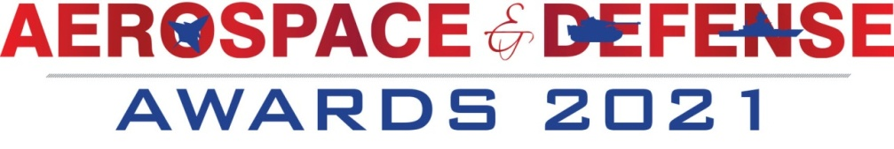

International Aerospace magazine in its 21th year of publication will host its 7th edition of the Aerospace & Defense Awards 2021. The Awards function will be held in Bangalore on 2th February 2021. The A&D Awards 2021 will be adjudged by high profile jury members from the cross section of the industries. These awards will be widely covered in Media and TV channels.

SAP Media Worldwide Ltd publishes Bi-monthly magazine International Aerospace, besides publishing over 12 Dailies under the brand name of SHOW DAILIES worldwide. This includes publishing in Aero India, Defexpo, Dubai Air Show, Wings India, Farnborough Air Show; Paris Air Show, Japan Aerospace, Seoul ADEX (Korea); Bahrain Air Show etc. Besides our bi-monthly International Aerospace Magazine, Sap Media is engaged in publishing various other titles with its HQ in Mumbai (India), having offices in New Delhi and Singapore.

Objective of the Awards
The objective of instituting the Aerospace & Defense Awards is to celebrate and applaud the excellence in various segments of the Aerospace & Defense Industry. The Awards offer a platform to celebrate and reward individuals, products &organizations.
Sap Media has a high-profile jury and advisory board from the cross section of the industry to evaluate and judge the Awards categories.

Goals
- To reward and award excellence in Aerospace &Defense Industry.
- To ensure high credibility, visibility for the Awards and the Sponsors across all media.
- To associate the Awards ceremony along with diverse publicity creating enhanced brand value and impact for both parties.

Categories

Awards for Indian and MNCs operating in India
- Company of the Year (to be decided by the jury based on overall score)
- Outstanding contribution in Aerospace Industry
- Outstanding contribution in Land Systems
- Outstanding contribution in Naval Systems
- Excellence in Innovation, Design, Technology or R&D
- Excellence in Exports
- Excellence in Contribution towards CSR activity
- MSME of the Year
- Best implementer of “Make-in India”
- Best implementer of “Offset policy “
- Best Aerospace Park/SEZ of the year
- Best Aerospace Park/SEZ of the year
- Outstanding contribution in bringing cutting-edge technology
- Best JV of the year
- Best Foreign OEM supporting Make In India

Personality Awards
- Business leader of the year
- Entrepreneur of the year
- Lifetime Achievement Award

Aerospace & Defense Awards 2021

Type | Amount | Deliverables
Platinum Sponsor | US$ 20,000  Rs.15.00 Lacs | Promotional Value to platinum Sponsor  - Vast exposure due to print and online media  - Enhanced brand impact as platinum sponsor of the high-profile Awards night.  - Prime logo Branding and placement under the platinum sponsor on all promotional literature  - Pre and post event coverage in the International Aerospace Magazine  - The name and logo to be mentioned on the pre and post event coverage across all media  - Big Banner on our website  - Four posts on social media page  Exclusive Benefits to Platinum Sponsor  - During the event platinum sponsor's name to be mentioned in all promotional material across all mediums.  - Coverage in pre and post event release sent out to the media  - Promotion through our website  - Promotion material round table on the awards night  - Branding space at the awards venue in form of standees (2 Standee)

Gold Sponsor(S) | US$15,000  Rs.10.00 Lacs | - Branding in all communication material related to the awards.  - Space for 2 standees at the awards venue  - Logo branding on all promotional literature of the event including online.  - Promotion material on the round table on the awards night  - Emcee mentions during the awards  - Coverage in pre and post event sent out to the media and TV channels  - Banner on our website  - Two posts on our Social media page
Silver Sponsor(S) | US$10,000  Rs.7.00 Lacs | - Branding in all communication material related to the award  - Space for 1 standee at the awards venue  - Logo branding in all promotional literature for awards including on-line  - Emcee mentions during the awards ceremony  - Coverage in pre and post event release sent out to the media.  - Two posts on our Social media page
Co-Sponsor(S) | US$4,000  Rs.3.50 Lacs |  | - Branding in all communication materiel related to the awards.  - Logo branding in all promotional literature for the awards including on-line  - Emcee mentions during the awards ceremony  - Coverage in pre and post event release sent out to the media and channels.  - One post in our social media

